Laiba Taseen
23-NTU-CS-1258
Embedded IOT Systems
Assignment-1

Question3
Task A:
#include <Arduino.h>
#include <Wire.h>
#include <Adafruit_GFX.h>
#include <Adafruit_SSD1306.h>

#define SCREEN_WIDTH 128
#define SCREEN_HEIGHT 64
Adafruit_SSD1306 display(SCREEN_WIDTH, SCREEN_HEIGHT, &Wire, -1);

// --- Pin Setup ---
#define LED1 23
#define LED2 25
#define BTN_MODE 18
#define BTN_RESET 19
#define BUZZER 13

// --- Variables ---
int mode = 0;
unsigned long lastPress = 0;
const int debounceDelay = 300;

// --- Function: short beep for feedback ---
void beep() {
digitalWrite(BUZZER, HIGH);
delay(100);
digitalWrite(BUZZER, LOW);
}

// --- OLED display function ---
void showMode(const String &text) {
display.clearDisplay();
display.setTextSize(1);
display.setTextColor(SSD1306_WHITE);
display.setCursor(10, 30);
display.println(text);
display.display();
}

// --- Reset button check function ---
bool resetPressed() {
if (digitalRead(BTN_RESET) == LOW && millis() - lastPress > debounceDelay) {
lastPress = millis();
return true;
}
return false;
}

// --- Turn everything OFF ---
void turnAllOff() {
pinMode(LED1, OUTPUT);
pinMode(LED2, OUTPUT);
digitalWrite(LED1, LOW);
digitalWrite(LED2, LOW);
digitalWrite(BUZZER, LOW);
showMode("Mode 0: Both OFF");
}

void setup() {
Serial.begin(115200);
Wire.begin(21, 22); // SDA=21, SCL=22

if (!display.begin(SSD1306_SWITCHCAPVCC, 0x3C)) {
Serial.println(F("OLED init failed"));
while (true);
}

pinMode(LED1, OUTPUT);
pinMode(LED2, OUTPUT);
pinMode(BUZZER, OUTPUT);
pinMode(BTN_MODE, INPUT_PULLUP);
pinMode(BTN_RESET, INPUT_PULLUP);

turnAllOff();
}

void loop() {
// --- Mode Change Button ---
if (digitalRead(BTN_MODE) == LOW && millis() - lastPress > debounceDelay) {
mode = (mode + 1) % 4;
lastPress = millis();
beep();
}

// --- Reset Button ---
if (resetPressed()) {
mode = 0;
beep();
turnAllOff();
return;
}

// --- LED Behavior ---
switch (mode) {
case 0: // Both OFF
turnAllOff();
break;

case 1: // Alternate blink
showMode("Mode 1: Alternate");
digitalWrite(LED1, HIGH);
digitalWrite(LED2, LOW);
for (int t = 0; t < 30; t++) {
if (resetPressed()) { mode = 0; turnAllOff(); return; }
delay(10);
}
digitalWrite(LED1, LOW);
digitalWrite(LED2, HIGH);
for (int t = 0; t < 30; t++) {
if (resetPressed()) { mode = 0; turnAllOff(); return; }
delay(10);
}
break;

case 2: // Both ON + Buzzer ON
showMode("Mode 2: Both ON");
digitalWrite(LED1, HIGH);
digitalWrite(LED2, HIGH);
digitalWrite(BUZZER, HIGH);
break;

case 3: // PWM fade
showMode("Mode 3: Fade");
digitalWrite(BUZZER, LOW);

// Attach PWM directly (Wokwi-compatible)
ledcAttach(LED1, 5000, 8);
ledcAttach(LED2, 5000, 8);

for (int i = 0; i <= 255; i++) {
if (resetPressed()) { mode = 0; turnAllOff(); return; }
ledcWrite(LED1, i);
ledcWrite(LED2, 255 - i);
delay(5);
}
for (int i = 255; i >= 0; i--) {
if (resetPressed()) { mode = 0; turnAllOff(); return; }
ledcWrite(LED1, i);
ledcWrite(LED2, 255 - i);
delay(5);
}

break;
}
}

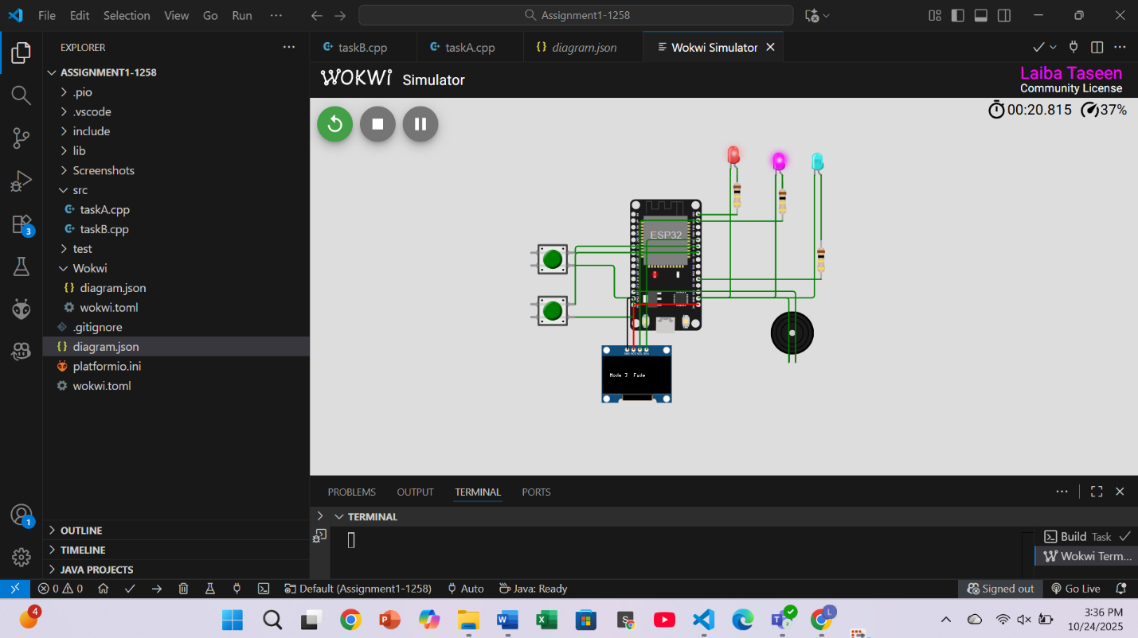
Task B:
// Task B - Fixed for Wokwi/ESP32 (short vs long press)
#include <Arduino.h>
#include <Wire.h>
#include <Adafruit_GFX.h>
#include <Adafruit_SSD1306.h>

#define SCREEN_WIDTH 128
#define SCREEN_HEIGHT 64
Adafruit_SSD1306 display(SCREEN_WIDTH, SCREEN_HEIGHT, &Wire, -1);

// --- Pin Definitions ---
#define BUTTON_PIN 18
#define LED_PIN 4
#define BUZZER_PIN 13

// --- Variables ---
unsigned long pressStart = 0;
bool buttonPressed = false;
bool ledState = false;
const unsigned long LONG_PRESS_TIME = 1500; // 1.5 seconds
const unsigned long DEBOUNCE_MS = 50;

// debounce + long press control
unsigned long lastBounce = 0;
bool longHandled = false;

// --- Helper: Display message on OLED ---
void showMessage(const char* msg) {
display.clearDisplay();
display.setTextSize(1);
display.setTextColor(SSD1306_WHITE);
display.setCursor(0, 20);
display.print(msg);
display.display();
}

void setup() {
Serial.begin(115200);
Wire.begin(21, 22); // SDA=21, SCL=22

if (!display.begin(SSD1306_SWITCHCAPVCC, 0x3C)) {
Serial.println(F("SSD1306 allocation failed"));
for (;;);
}

display.clearDisplay();
display.display();

pinMode(BUTTON_PIN, INPUT_PULLUP);
pinMode(LED_PIN, OUTPUT);
pinMode(BUZZER_PIN, OUTPUT);
digitalWrite(LED_PIN, LOW);

// --- Setup buzzer PWM (newer ESP32 cores support ledcAttach) ---
ledcAttach(BUZZER_PIN, 2000, 8); // pin, frequency, resolution (8-bit)
ledcWrite(BUZZER_PIN, 0); // start silent

showMessage("Ready...");
}

void shortPressAction() {
ledState = !ledState;
digitalWrite(LED_PIN, ledState ? HIGH : LOW);
showMessage("Short Press:\nLED Toggled");
Serial.println("Short press");
}

void longPressAction() {
showMessage("Long Press:\nBuzzer Tone");
Serial.println("Long press");

// Play 500ms tone
ledcWrite(BUZZER_PIN, 200); // 50% duty -> audible tone
delay(500);
ledcWrite(BUZZER_PIN, 0); // stop tone
}

void loop() {
int reading = digitalRead(BUTTON_PIN);

// pressed
if (reading == LOW && !buttonPressed && (millis() - lastBounce) > DEBOUNCE_MS) {
buttonPressed = true;
pressStart = millis();
longHandled = false;
lastBounce = millis();
}

// held down
if (buttonPressed && !longHandled && (millis() - pressStart) >= LONG_PRESS_TIME) {
longPressAction();
longHandled = true;
}

// released
if (reading == HIGH && buttonPressed && (millis() - lastBounce) > DEBOUNCE_MS) {
unsigned long pressDuration = millis() - pressStart;
buttonPressed = false;
lastBounce = millis();

if (!longHandled && pressDuration < LONG_PRESS_TIME) {
shortPressAction();
}

longHandled = false;
}

delay(5);
}

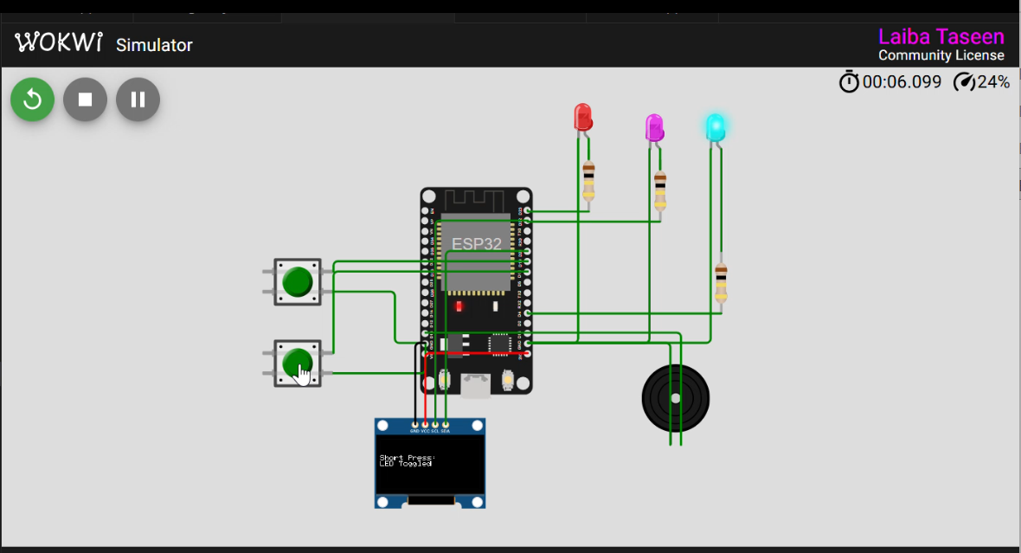

Hand Sketch:
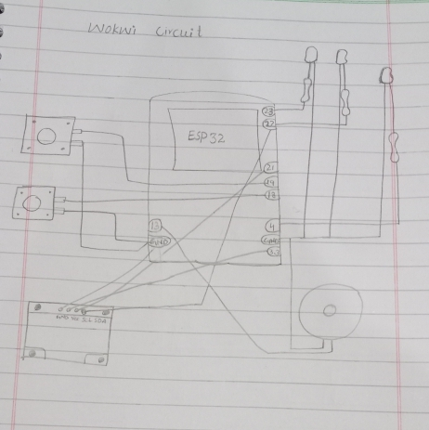

GitHub Link:
https://github.com/LaibaTaseen/Embedded-IOT-1258-/tree/master/Assignment1-1258

